WorkHorse Z-Axis Lead Screw Mount
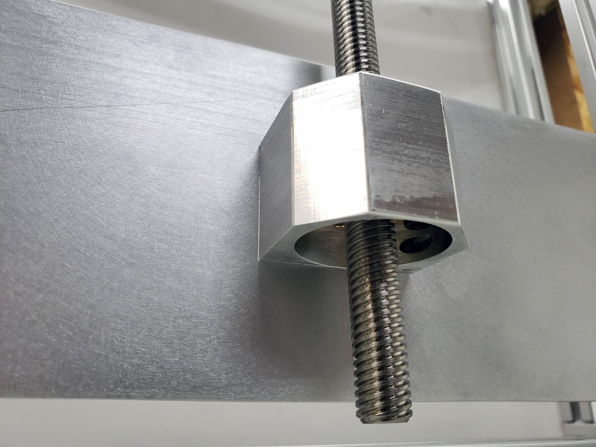

Z-Axis Mount
Download 3D Model
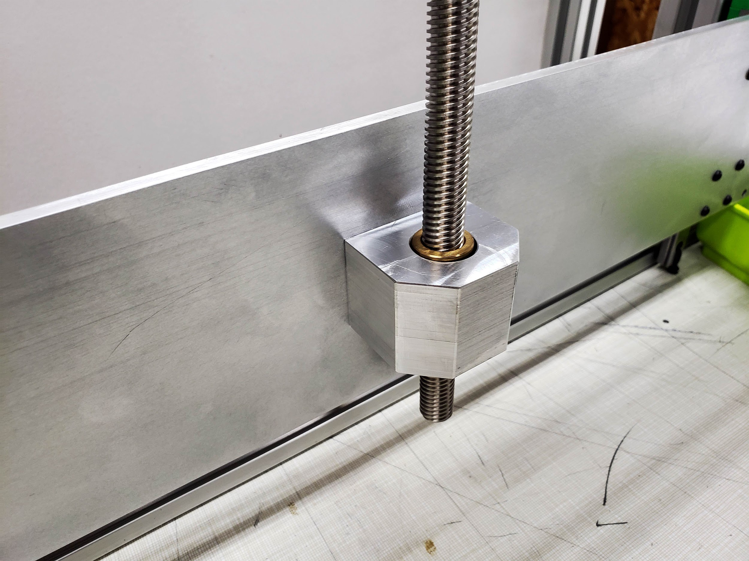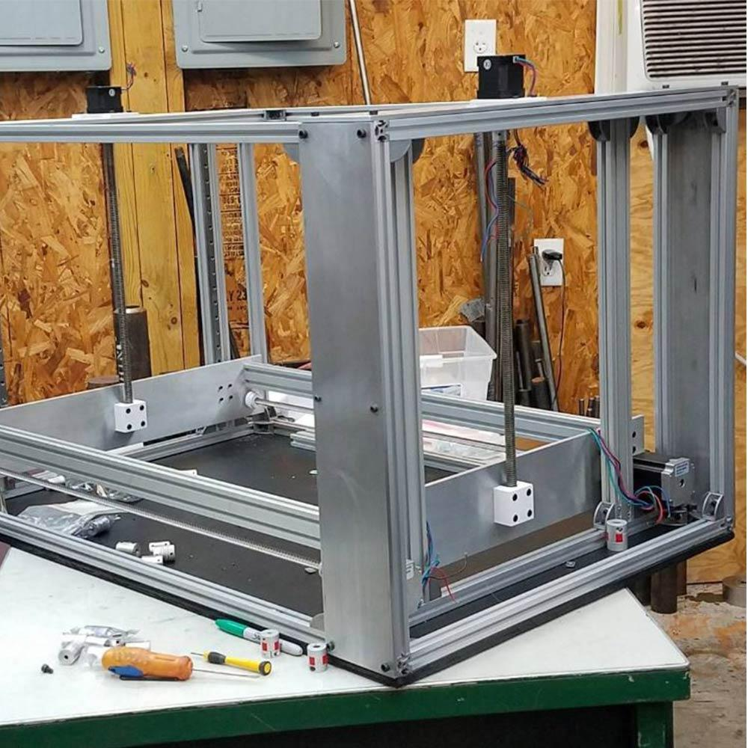

Related Content
Workhorse 3D Printer
Workhorse 3D Printer CAD
3D Distributed
WorkHorse Documentation
WorkHorse BOM
Z-Axis Dimensions

